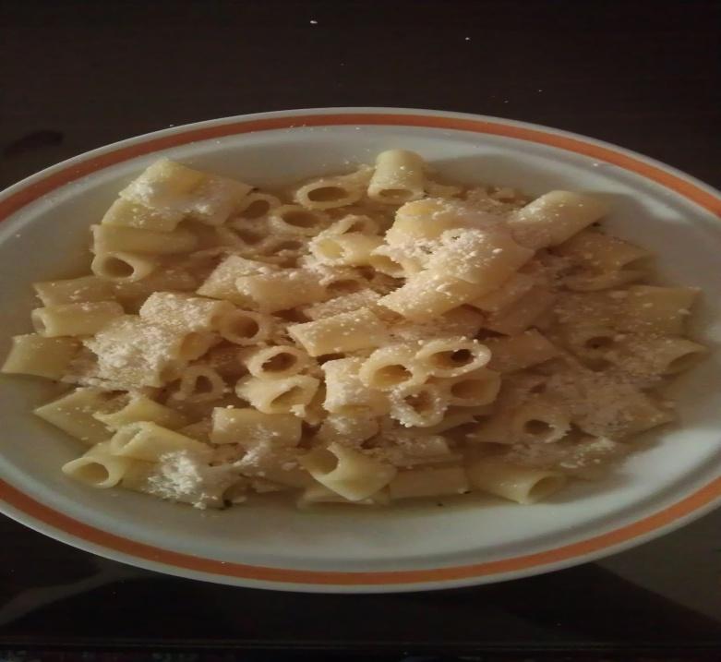
INGREDIENTS
500 g. pasta
Olive oil
Salt
Pepper
1lt water
Carrots
Thyme
Cheese (for the serving)

MAKING
We boil the pasta into the water for 10 minutes and also we add the salt, the pepper, the olive oil, the thyme and carrots. We drain the water but first we must had picked the carrots. Finally, we serve on a plate with the carrots and the cheese.

GOOD APPETITE.

